Section 1

Snippet 1:

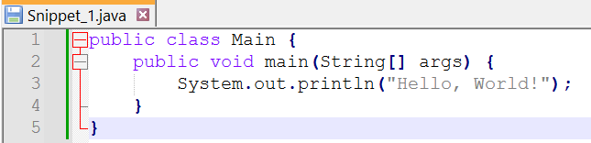

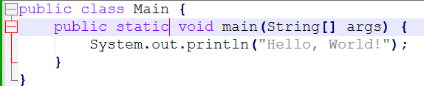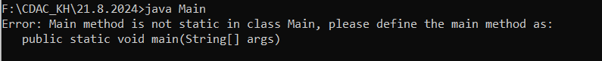Error: Main method Shoud be static

Result:-

Snippet 2:

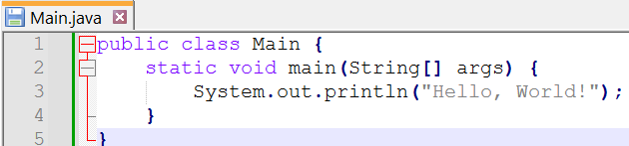

Error : Main method Should be Public as class is defined as public

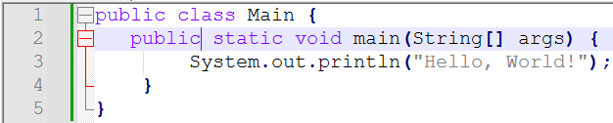

result



Snippet 3:

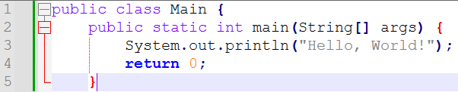

Error : Incomplete Curly Bracket and also main method does not return any value so main method should be void instead of int



Result :

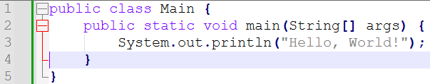



Snippet 4:

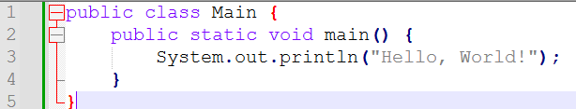

String[] args

Error : Parameters of main method must me mentioned



Corrected Code :

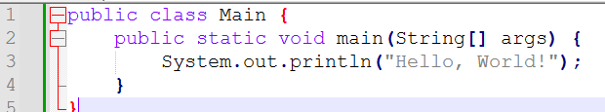

Result:



Snippet 5:

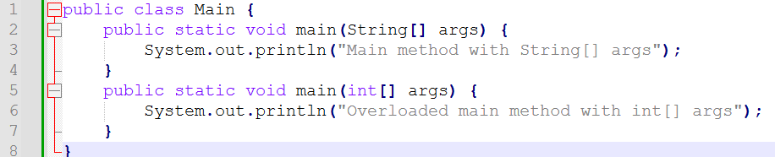

Errors: One Java file contain only one main method to call another method and perform respective operations but in given code snippet there are 2 Main methods only one which is at top will execute. if we want to execute another method also then need to change the method name and should be called from main method

Result



Snippet 6:

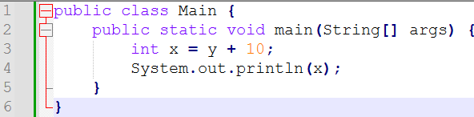

Error: Here Variable ‘Y’ is not declared Y should be declare as well as initialize otherwise we can take input from user

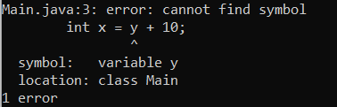

Corrected Code :

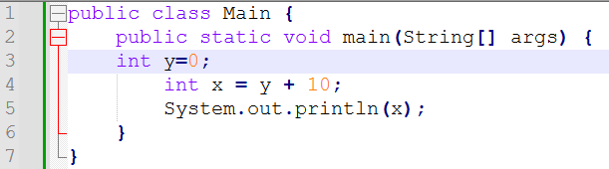

Result:



Snippet 7:

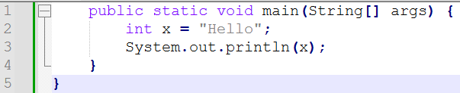

Error: 1) here in this code snippet the class is not declared Java code does not start without creating class ,So we need to add respective class and required parenthesis .

2) ‘X’ is declared as int but provided value is string type we need to change either datatype of X or value of X

Corrected Code :

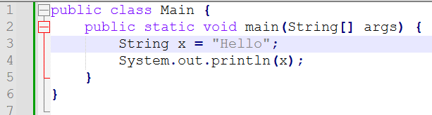

Result:



Snippet 8:

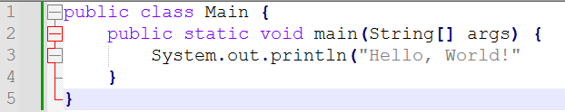

Error : Incomplete Parenthesis

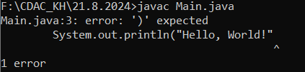

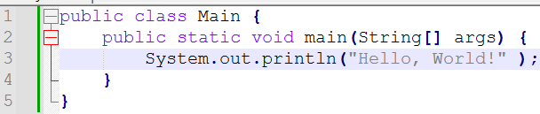Corrected Code :

Result:

Snippet 9

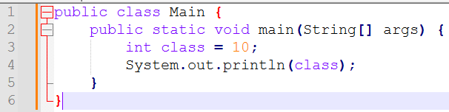

Errors: 1) name of variable could not be “Class” which is key Word.

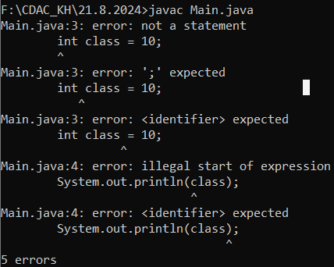

Corrected Code:

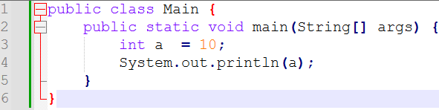

Result:



Snippet 10

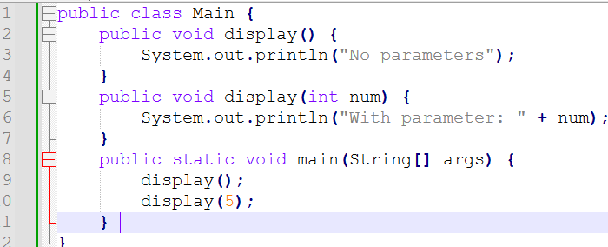

Error : Non static methods called by static main method

Corrected code:

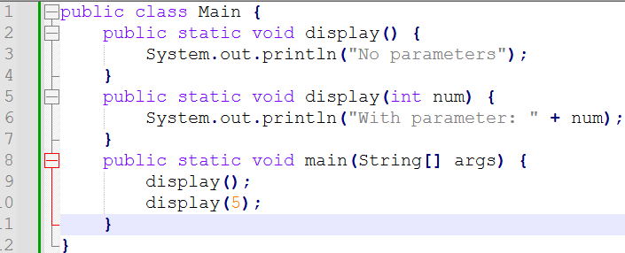

Result:

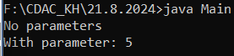

Snippet 11:

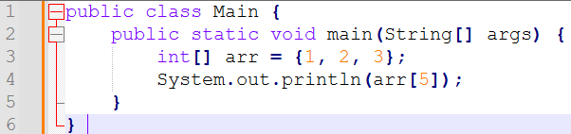

Error: print call for array is out of range of declared array which is only Two(2) as array starts from index ‘0’ need to reduce the array call or need to extend the array

Corrected Code:

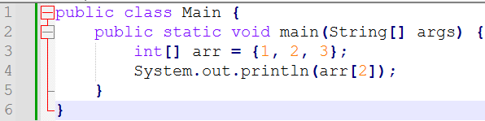

Result:



Snippet 12

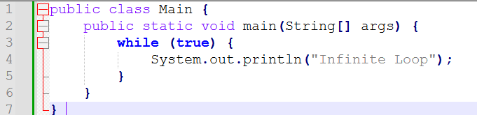

Error: While condition is always true that’s why the snippet code is become infinite loop, actually this code is not error code but infinite loop to stop the infinite loop need to add the limit to while loop or need to replace true with false to avoid the loop

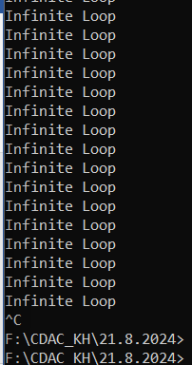

Corrected code:

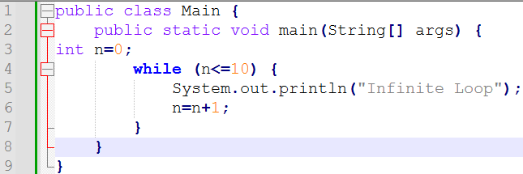

Result:

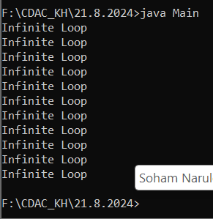

Snippet 13:

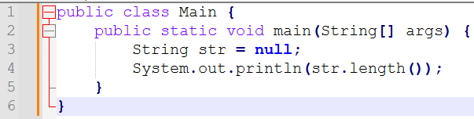

Error : Null string does not contain any value so it not have any length



Corrected Code

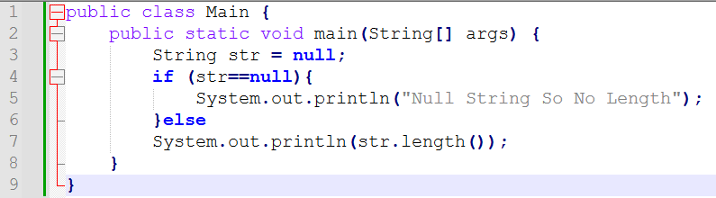

Result:



Snippet 14:

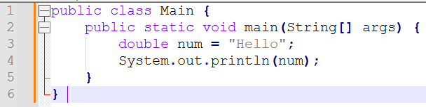

Error: the data type of variable is double and value assigned to that variable is string so we need to change the data type according to value which is string

Corrected code :

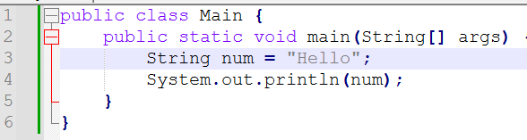

Result:



Snippet 15:

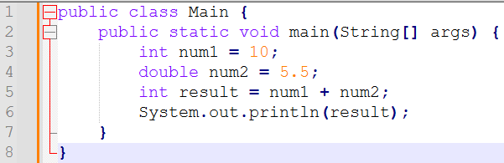

Error: in the result variable which is the arithmetic operation which contains two variables one of them is int type and one of them is double type after the arithmetic operation which is addition operation whose result will store in integer type variable to avoid the error both operation variables must be with same data type for that we need to do type casting for one of them variable same as result data type.

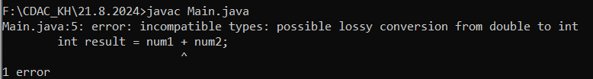

Corrected code:

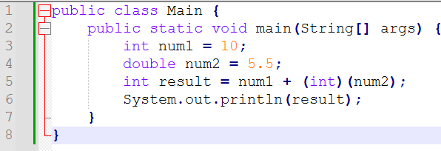

Result:



Snippet 16:

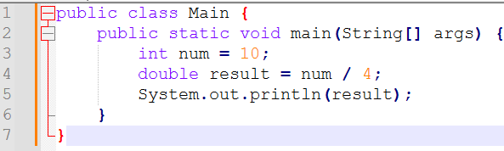

Error : in the result variable, which is the arithmetic operation which contains two variables one of them is integer type and one of them is double type after the arithmetic operation which is division operation whose result will store in double type variable to avoid the error both operation variables must be with same data type for that we need to do type casting for one of them variable same as result data type.

Corrected Code:-

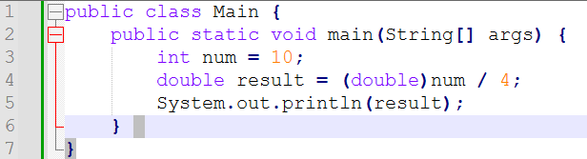

Result:



Snippet 17: For the Multiplication in java only single star symbol is used.not TWO star required .

Corrected code :

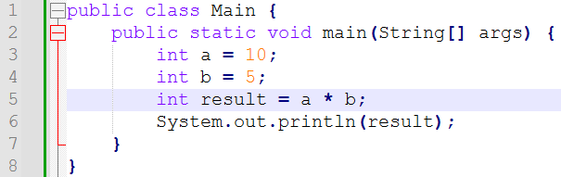

Result:



Snippet 18:

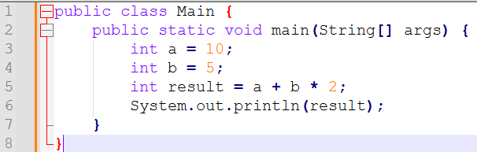

Error: According to above arithmetic operation arrangement the ans of operation is illegal according to BODMOS rule to get accurate answer need to add some brackets.

Corrected code:

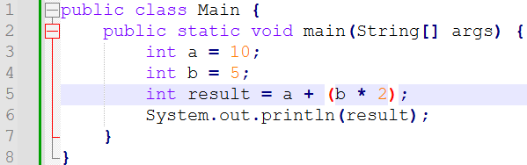

Result:



Snippet 19:

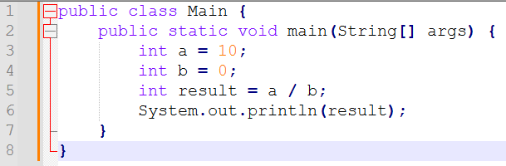

Error : Denominator of division operation is zero so it become infinite or invalied to remive that error we need to appy for loop for zero or non-zero denominator



Corrected Code :

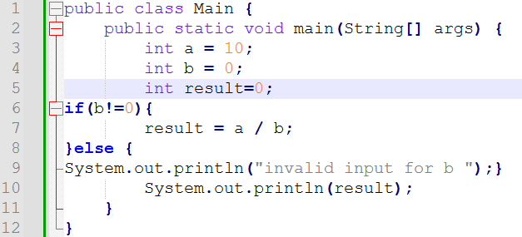

Result:

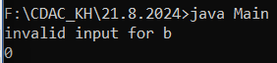

Snippet 20:

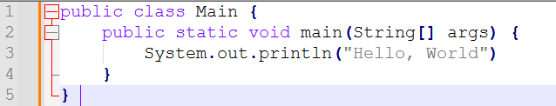

Error: To complete the statement in java semicolon is required to end the sentence which is missing in the above snippet.

Corrected Code :

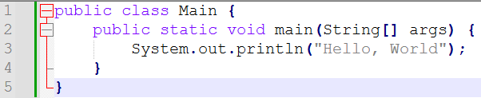

Result:



Snippet 21

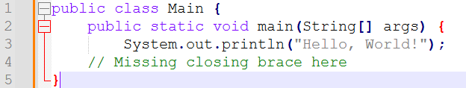

Error : Closing Bracket Missing.

Corrected Code:

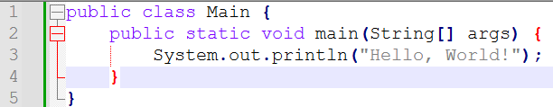

Result:



Snippet 22:

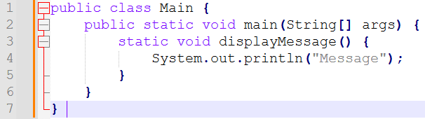

Errors: We cant add one method into another method

Corrected code :

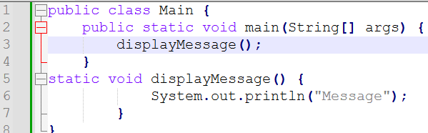

Result:



Snippet 23:

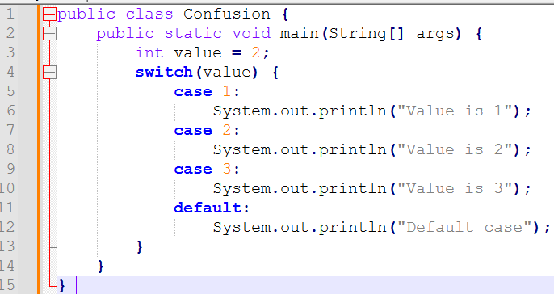

Error : Missing the break statement after the case

Corrected Code:

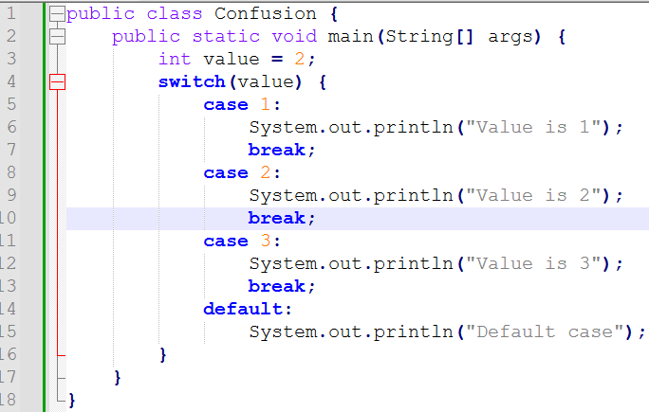

Result:



Snippet 24:

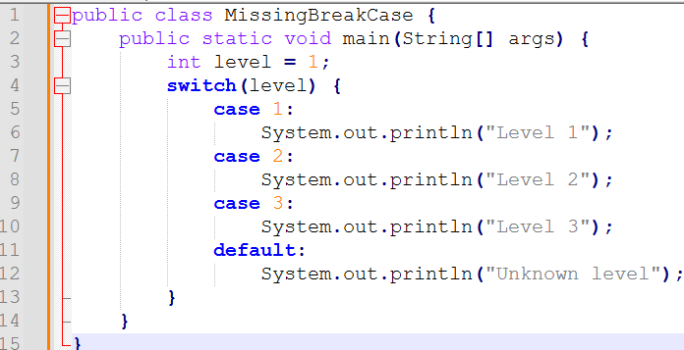

Error: other cases also running due to missing of break statement. break statement exits the loop

Corrected Code:

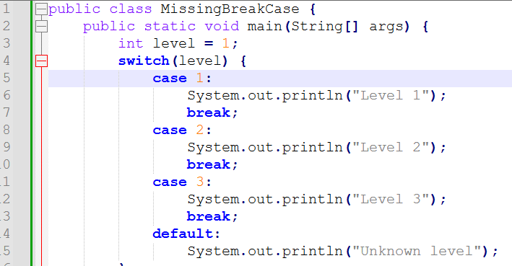

Result:



Snippet 25

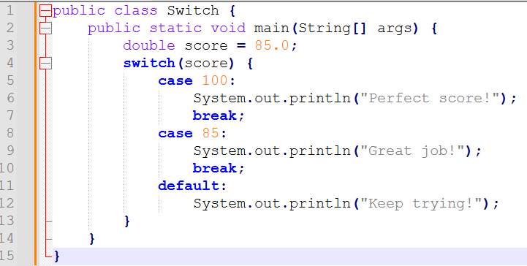

Error: As We Know Switch Case only take integer and string Input for case number but in provided snippet input for case is double data type need to change datatype

Corrected Code :

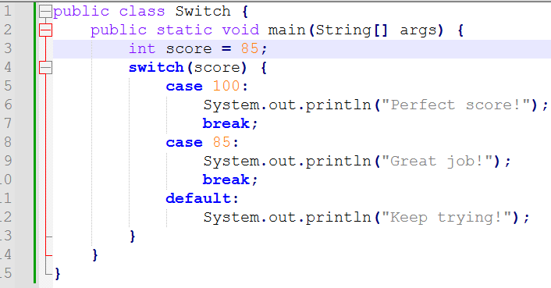

Result :



Snippet 26:

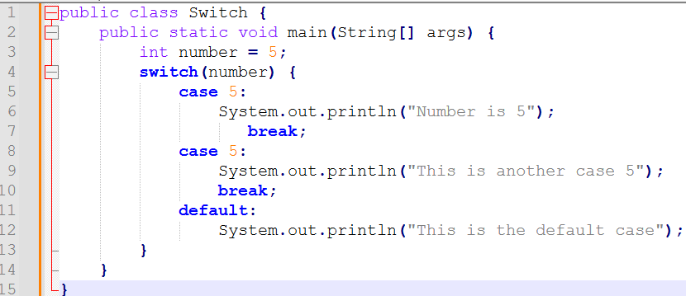

Error: There are multiple cases with same case number so first one will execute and exits the loop.

Corrected Code:

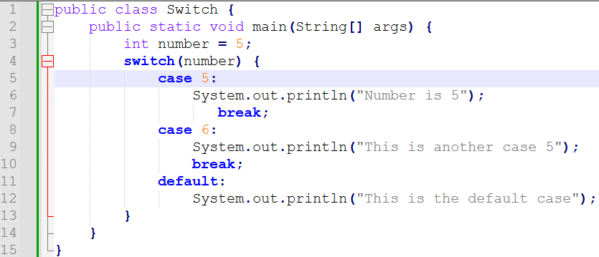

Result:



SECTION 2

QUESTION 1:

Solution Code:

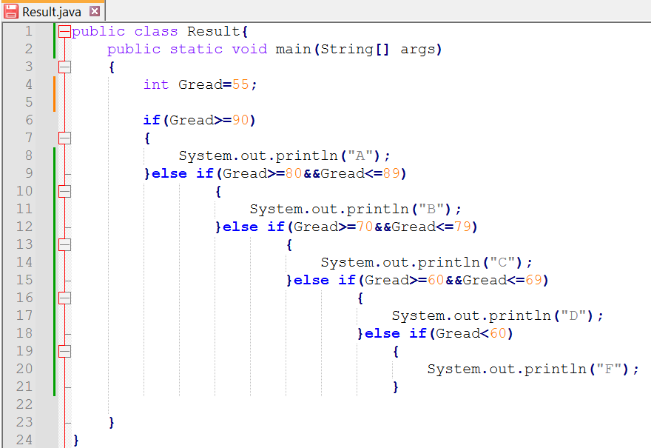

Result :



Question 2:

Solution Code :

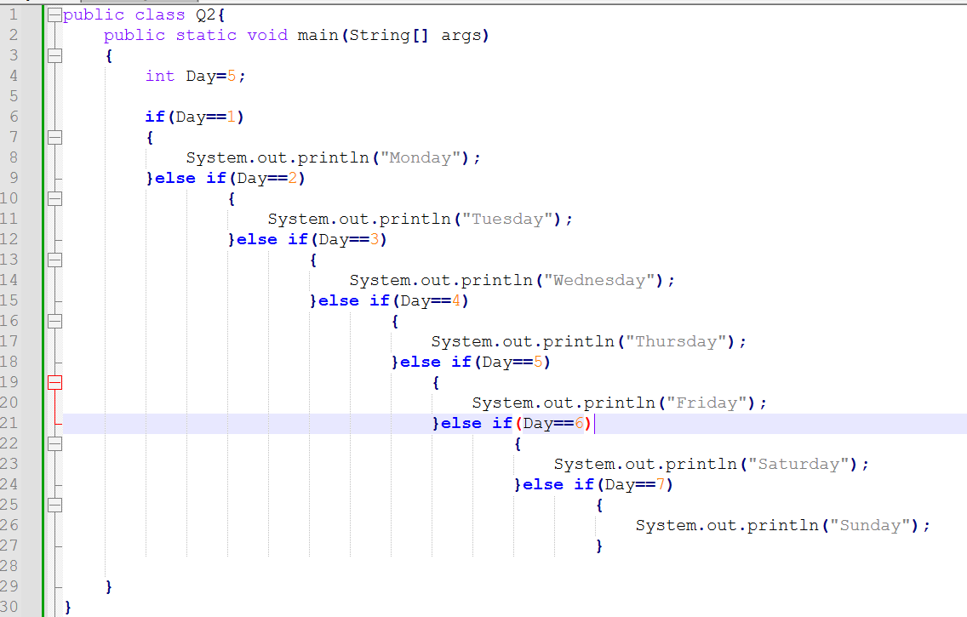

Result :



Question 3:

Solution Code :

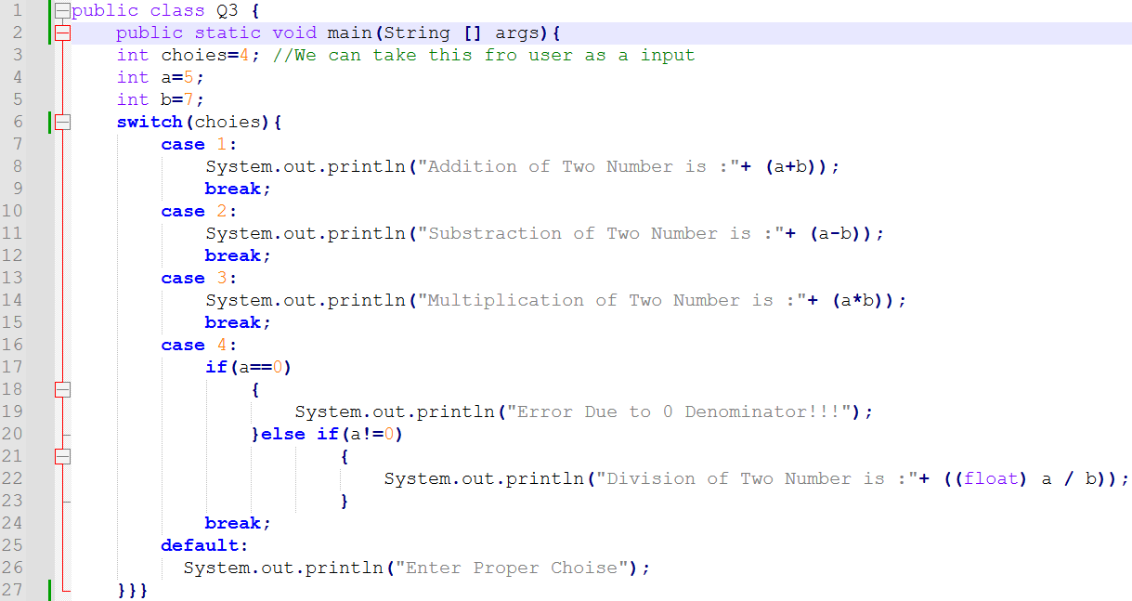

Result:



Question 4:

Solution Code :

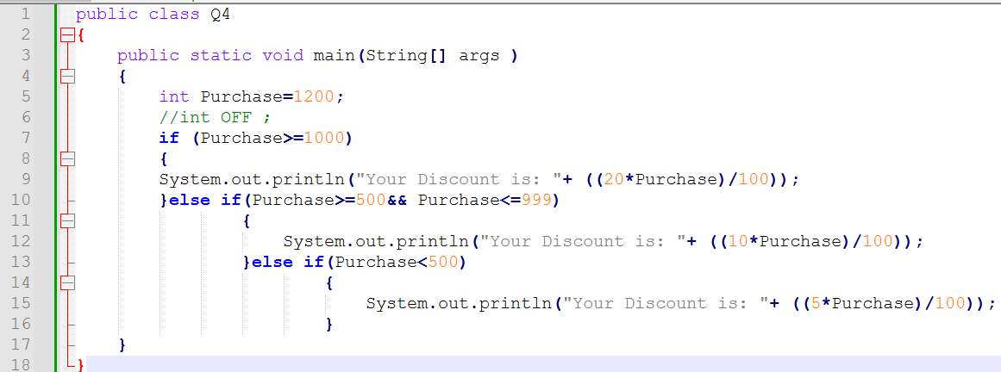

Result:



Question 5:

Solution Code:

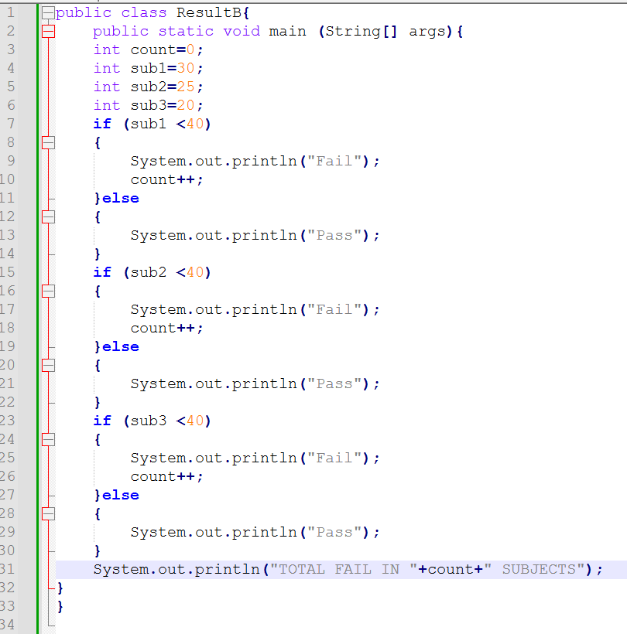

Result :

